Solution Architecture

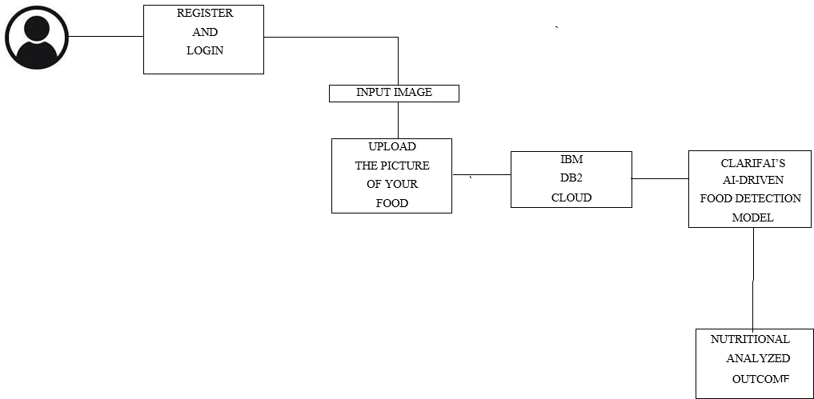

USER

|  |  |
| --- | --- |
| Date | 15 October 2022 |
| Team ID | PNT2022TMID51895 |
| Project Name | Nutrition assistant application. |